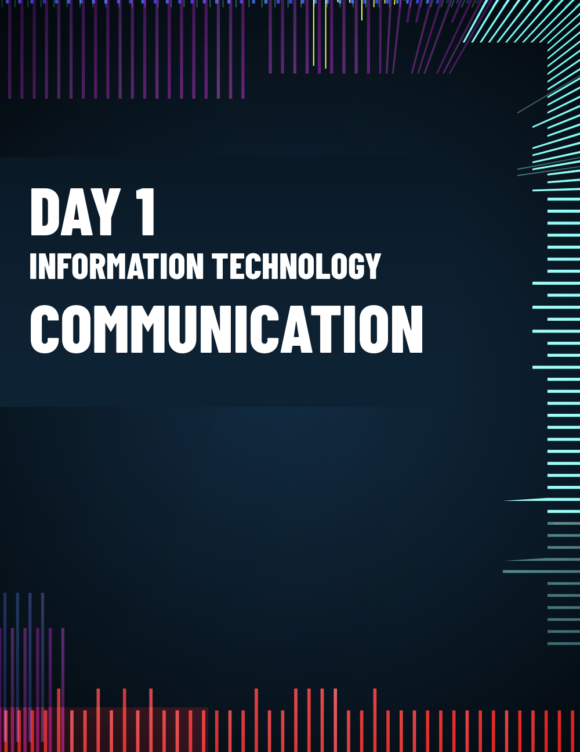


Employees,
As part of the Acquirer’s integration, I wanted to make you aware of some upcoming IT-related changes which will provide you with connectivity to the Acquirer’s network and migrate all laptops and computers to Acquirer’s standard configurations and business systems. These changes will impact both employees and contractors.

Network Upgrades (January 1 – January 31)
We will install the Acquirer‘s standard firewall platform (replacing existing firewalls), VMWare platform, and wireless access points (replacing existing access points). We will also upgrade the switches used in the network infrastructure.
Impact on you
Your existing VPN process for remote access will change to Nord VPN. Instructions for using Global Protect will be provided and VPN access will only be available on Acquirer and Acquiree owned devices. Acquirer’s security policies prohibit the use of any other remote access platforms or the use of Nord VPN on any personally owned devices.
Two new wireless networks will be accessible on your computer and will replace the existing wireless network:
- Green is for use by employees – you will use your Acquirer’s network user ID and password credentials.
- Red is for use by guests – you will be provided with a general user ID and password to use for guests and guests may only use the red network.
Note: the existing Acquiree wireless network and VPN platform will continue to be available until December 11.
Computer Updates (January 20 - February 10)
An Acquirer-appointed local IT company will assist with the following:
- Installation of Nord VPN (VPN for remote access), Crowd Strike (anti-virus / anti-malware platform), Carbonite (for automatic backup), the latest operating systems, and agents to assist with asset management and future software updates.
- MS Teams set up – Acquirer’s standard collaboration platform.
- Conversion of your standard email to Acquirer’s Office 365 platform:
  - Your Acquiree email files will be downloaded and stored in a pst file on your computer.
  - Your Acquiree email will be forwarded to your Acquirer’s account.
  - Acquirer’s email will become the standard email platform on your computer – which will mean you have just one email account to manage going forward (Acquiree.com email accounts will no longer be in use).
  - Regarding syncing email to mobile devices:
    - Syncing email to mobile devices that are part of an Acquiree (or Acquirer) corporate plan will be automatically approved – please submit a ticket via the helpdesk platform to request syncing.
    - Syncing email to a personally own device will be approved, provided an agreement is completed – submit a ticket via the helpdesk platform to request syncing. You will be provided with a copy of the agreement to sign once your ticket has been submitted.

Impact on you
The updates outlined above will take 4 to 6 hours per computer and a limited number of loaner computers will be available for use while computers or laptops are being updated.
Updates will be organized as follows:
- Denver employees – John Grote will work with you to schedule approximate times.
- Remote employees local to Denver – your updates will be scheduled separately, and you will be asked to drop off your computer or laptop at the Denver office.
- Remote users not local to Denver - your updates will be scheduled separately, and you will be provided with further information soon.
- Houston employees – IT personnel in Acquirer’s Houston office will work with you to complete the updates.
We expect to complete updates for all Acquiree employees by December 11. After this date, the existing Acquiree platforms for the wireless network and remote access will be shut down.
Business Systems Migration (February 11 Cutover)
We will be migrating to Acquirer’s standard business systems platforms as described below:
- Oracle for the ERP systems (all transactions related to order processing, finance, manufacturing, shipments, and purchasing)
- Salesforce, for all customer-related processes (opportunities, quotes, order booking, asset tracking, RMAs and customer service requests, etc.)
- Delogue, for all product data management (part number management, bills-of-material, ECOs, etc.)
- Zoho, for reporting and analytics
Impact on you
You will be invited to attend systems training, as required, before the cutover date. After January 12, you will no longer be able to use legacy Acquiree systems for transactions.
What is not changing?
You will continue to have access to and use SharePoint, and existing Acquiree development and engineering tools.

Zoom will still be used for web-conferencing, but we will transition you to Acquirer’s Zoom account in the future. You will be notified once the transition schedule is finalized.

Have questions or need IT support?
Contact Jim Davis in IT if you have questions regarding the above. For IT support, submit a ticket via the help desk platform.
We appreciate you taking the time to review this lengthy but important communication. We will do our best to minimize the disruption caused by the network, computer, and business system changes outlined above. These changes will help provide the necessary levels of technological security required for both Acquirer and Acquiree.
Thanks in advance for your support and co-operation!
Best regards,
CIO

